Gilbert Present | Death on Shift  Yes No |  | Total
Yes | 40 | 217 | 257
No | 34 | 1,350 | 1,384
Total | 74 | 1,567 | 1,641

Table 1. The data for the statistical analysis in the Gilbert Case.
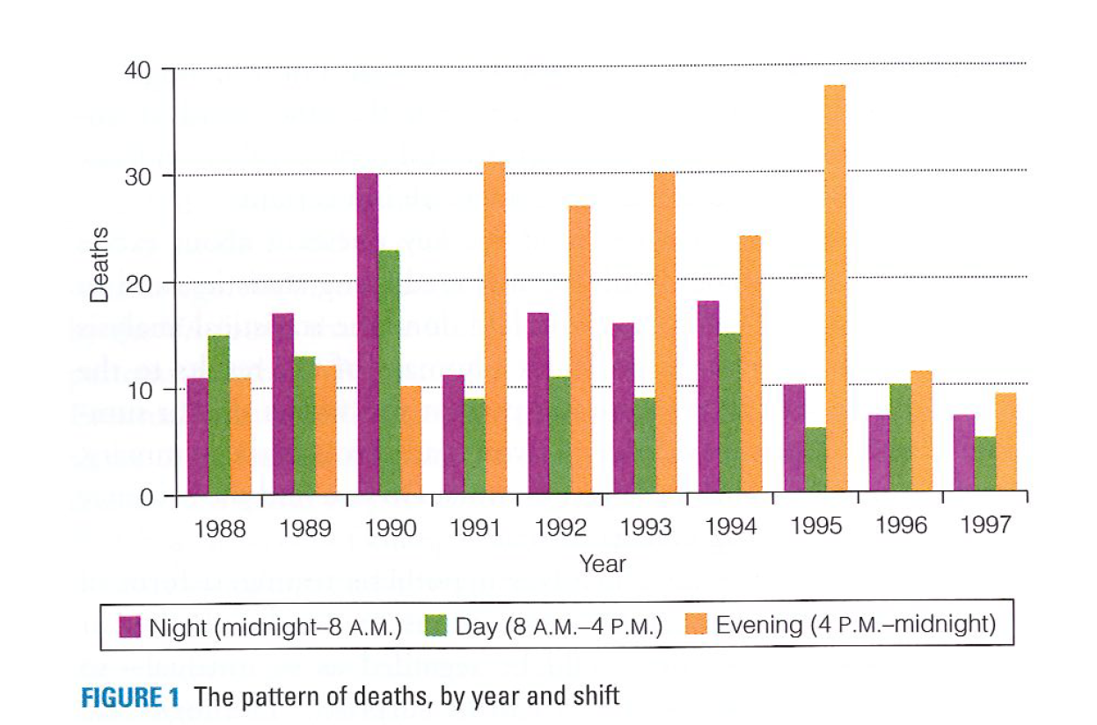

- Kristen Gilbert worked at the hospital from 1990-1995. The night shift in 1995 and Evening shift in 1991-1995. Do you notice an increase or decrease in the number of deaths from the bar chart?

- What is the probability of deaths on all the shifts?

- What is the null and alternative hypothesis?

- Based on this probability, how many deaths would we expect on Gilbert’s shift?

- Compare the expected number of death’s to Gilbert’s vs. the actual number of deaths on Gilbert’s shift.

- A statistician ran a simulation similar to a coin toss and calculated that the probability of having 40 or more of the 74 deaths occur on Gilbert’s shifts was less than 1 in 100 million.
As the statistician on this case, what do you think is the correct decision for Gilbert?

- Discuss the Type I error and Type II error within the context of this case. Which error is more serious here?

- This statistical analysis provided enough evidence for a grand jury indictment. However, this data was not shared at the actual trial due to it being observational evidence. Read p.12-13 in the pdf.

